



**SECP 1513**

**TECHNOLOGY AND INFORMATION SYSTEM**



**DESIGN THINKING**

**LECTURER:**

**DR AZURAH ABD SAMAH**

**SUBMITTED BY:**

| **NAME** | **MATRIC NO.** |
| --- | --- |
| **MUHAMMAD LUQMAN BIN MOHD AZMI** | **A24CS0138** |
| **NUR ATHIRAH BINTI ABASA** | **A24CS0158** |
| **BATRISYIA AMANI BINTI KHAIRUN HALED** | **A24CS0054** |
| **TAN HUI SHAN** | **A24CS0197** |

**Semester 1 2024/2025**

**GROCER4U APP**

Faculty of Computing

Universiti Teknologi Malaysia, 81310 Skudai,

Johor Bahru, Malaysia

**Table of Contents**

**Table of Contents . . . . . . . . . . . . . . . . . . . . . . . . . . . . . . . . . . . . . . . . . . . . . . . . . . . . . . . . . . .2**

**Abstract . . . . . . . . . . . . . . . . . . . . . . . . . . . . . . . . . . . . . . . . . . . . . . . . . . . . . . . . . . . . . . . . . .3**

**Introduction . . . . . . . . . . . . . . . . . . . . . . . . . . . . . . . . . . . . . . . . . . . . . . . . . . . . . . . . . . . . . . .3**

**Problem Background . . . . . . . . . . . . . . . . . . . . . . . . . . . . . . . . . . . . . . . . . . . . . . . . . . . . . . . 4**

**Methodology**

i) Empathize . . . . . . . . . . . . . . . . . . . . . . . . . . . . . . . . . . . . . . . . . . . . . . . . . . . . . . . . . 5

ii) Define. . . . . . . . . . . . . . . . . . . . . . . . . . . . . . . . . . . . . . . . . . . . . . . . . . . . . . . . . . . .5

iii) Ideate. . . . . . . . . . . . . . . . . . . . . . . . . . . . . . . . . . . . . . . . . . . . . . . . . . . . . . . . . . . .6

iv) Prototype. . . . . . . . . . . . . . . . . . . . . . . . . . . . . . . . . . . . . . . . . . . . . . . . . . . . . . . . . 6

v) Test. . . . . . . . . . . . . . . . . . . . . . . . . . . . . . . . . . . . . . . . . . . . . . . . . . . . . . . . . . . . . 6

**Features of Products . . . . . . . . . . . . . . . . . . . . . . . . . . . . . . . . . . . . . . . . . . . . . . . . . . . . . . . . 7**

**User Study . . . . . . . . . . . . . . . . . . . . . . . . . . . . . . . . . . . . . . . . . . . . . . . . . . . . . . . . . . . . . . . 10**

**Capacity Building and Soft Skills Development . . . . . . . . . . . . . . . . . . . . . . . . . . . . . . . . .12**

**Reflection and Conclusion . . . . . . . . . . . . . . . . . . . . . . . . . . . . . . . . . . . . . . . . . . . . . . . . . . 12**

**Task Distribution . . . . . . . . . . . . . . . . . . . . . . . . . . . . . . . . . . . . . . . . . . . . . . . . . . . . . . . . . .16**

**Attachment . . . . . . . . . . . . . . . . . . . . . . . . . . . . . . . . . . . . . . . . . . . . . . . . . . . . . . . . . . . . . . .16**

**ABSTRACT**

This paper describes an application named GROCER4U which provides solutions to common problems faced by the elderly who might struggle with grocery shopping, particularly for essentials. Background of users and problems faced by users are also discussed to give a better understanding of the real problems faced by different individuals. Analysis of user study is presented in this paper to justify the problems surrounding the needs of GROCER4U. Results of analysis shows that the features in GROCER4U address and accommodate most of the common problems faced by the users in their daily lives.

1. **INTRODUCTION**

For the elderly, especially those living alone, maintaining a well-stocked kitchen and managing everyday groceries can be a difficult and overwhelming task. Going out to shop for essentials, or even keeping track of what's in the fridge, can become increasingly challenging with age. This is where GROCER4U comes in – a user-friendly app designed specifically for elderly individuals to conveniently purchase groceries online and have the groceries delivered directly to their doorsteps.

GROCER4U is not just a grocery delivery service. It goes the extra mile to ensure that users can manage their kitchen efficiently. With features like tracking expiration dates of food items and suggesting healthy recipes based on the purchase, the app simplifies daily life, making it easier for elderly individuals to enjoy fresh meals without the worry of running out of essentials or forgetting about expired items. By providing these services, GROCER4U helps the elderly stay independent, healthy, and connected, all while eliminating the stress of traditional grocery shopping.

1. **PROBLEM BACKGROUND**

For the elderly, particularly those who live alone, maintaining a well-stocked kitchen and ensuring access to fresh groceries can pose significant challenges. Many elderly face mobility issues such as lack of transportation, or other health problems that make it difficult for them to visit stores. Without support, this can lead to missed meals, improper nutrition, and even lack of basic food essentials.

Another challenge is the ability to keep track of groceries, especially expiration dates. As we age, memory and organization skills may decline, leading to consumption of expired items, which may lead to health risks. Many elderly individuals also struggle to plan meals and shop for ingredients in advance, making it hard to maintain a balanced diet.

These elderly individuals may not have regular visitors or family members who lived nearby to help with grocery shopping, forcing them to face the task alone. GROCER4U aims to solve these problems by providing a convenient solution for the elderly to shop groceries online, with delivery right to their doorsteps. This service eliminates the physical barriers that prevent elderly from managing their food needs, helping them to stay healthy.

1. **METHODOLOGY**

**Empathize Mode**

***Observation***

Based on our observations and experience, the seniors tend to struggle when it comes to shopping for basic daily needs. It is due to many factors, such as health concerns, safety issues, lack of transport and many more. A lot of seniors are currently living alone without any caretakers, and that alone shows that we must take action to think of a solution. We take this problem seriously since the seniors really need to keep track of their daily food consumption. It is because they are more exposed to the risk of getting sick due to their low immune system.

***Engage (interview)***

Interviews conducted through spontaneous encounters revealed that most users face challenges with managing grocery expiration dates and sometimes accidentally purchase duplicate items, leading to waste. They showed interest in the GROCER4U app, appreciating the idea of a grocery delivery service that could address these issues. However, users expressed concerns about the safety and privacy of their data, emphasizing the need for secure handling of personal information.

**Define Mode**

All of our group members have done analysis and research in order to develop a better and deeper understanding regarding our users and design space. As a result, we have managed to come up with an idea, which is to create an app that is capable of solving multiple problems stated in the empathize mode. We believe that mobile phones are currently a necessity in our daily life. Hence, the idea to create an app might be our next step to solve many more problems.

**Ideate Mode**

We have managed to think of many ideas to design our app by brainstorming ideas. We also discussed the main features in our app that mainly target our users' problems. Furthermore, we worked together to sketch a logo, user’s interface and tons more innovations and ideas that can be added in our app. Many of the ideas suggested were related to our user (the elderly) so that it is suitable and easy for them to use.

**Prototype Mode**

During this phase, we created a slide as our prototype in a digital form. We presented what is within the app so that users will understand the concept of our app. We showed that the app is user-friendly by using soft pastel colours, and we also asked users to choose . In this phase, we also managed to contribute more ideas that might allow improving our app in the future.

**Test Mode (interview)**

To refine the design and make it better, we have explained our product to the user for responses. We asked for users’ experiences in order to establish a more comprehensive way to solve the problem. Test mode helps us to identify previously unconsidered problems.

1. **FEATURES OF PRODUCT**

Problems faced by users have motivated the development of GROCER4U, a grocery delivery service application that can be downloaded in smartphones and tablets. Upon opening the app, users are prompted to choose their preferred language. This ensures that the app is accessible to a wide range of users, catering to different linguistic needs.

 

*Figure 1: Logo of GROCER4U app Figure 2 : Page to choose language*

Users can quickly set up their account by providing username, password, and phone number. They can also link their account with Google or Facebook. Once the account is set up, users can customize their preferences in food intake. This to give users a recipe suitable for their dietary needs after checking out.

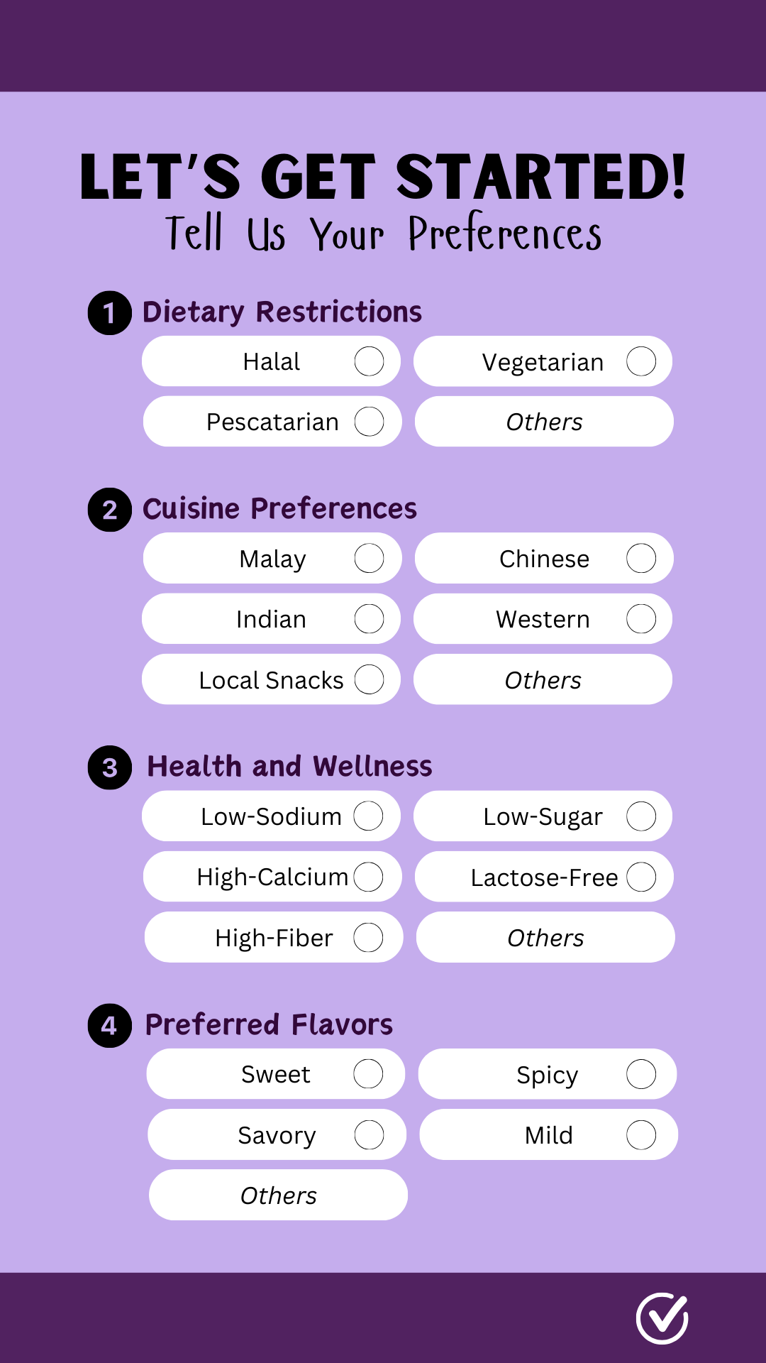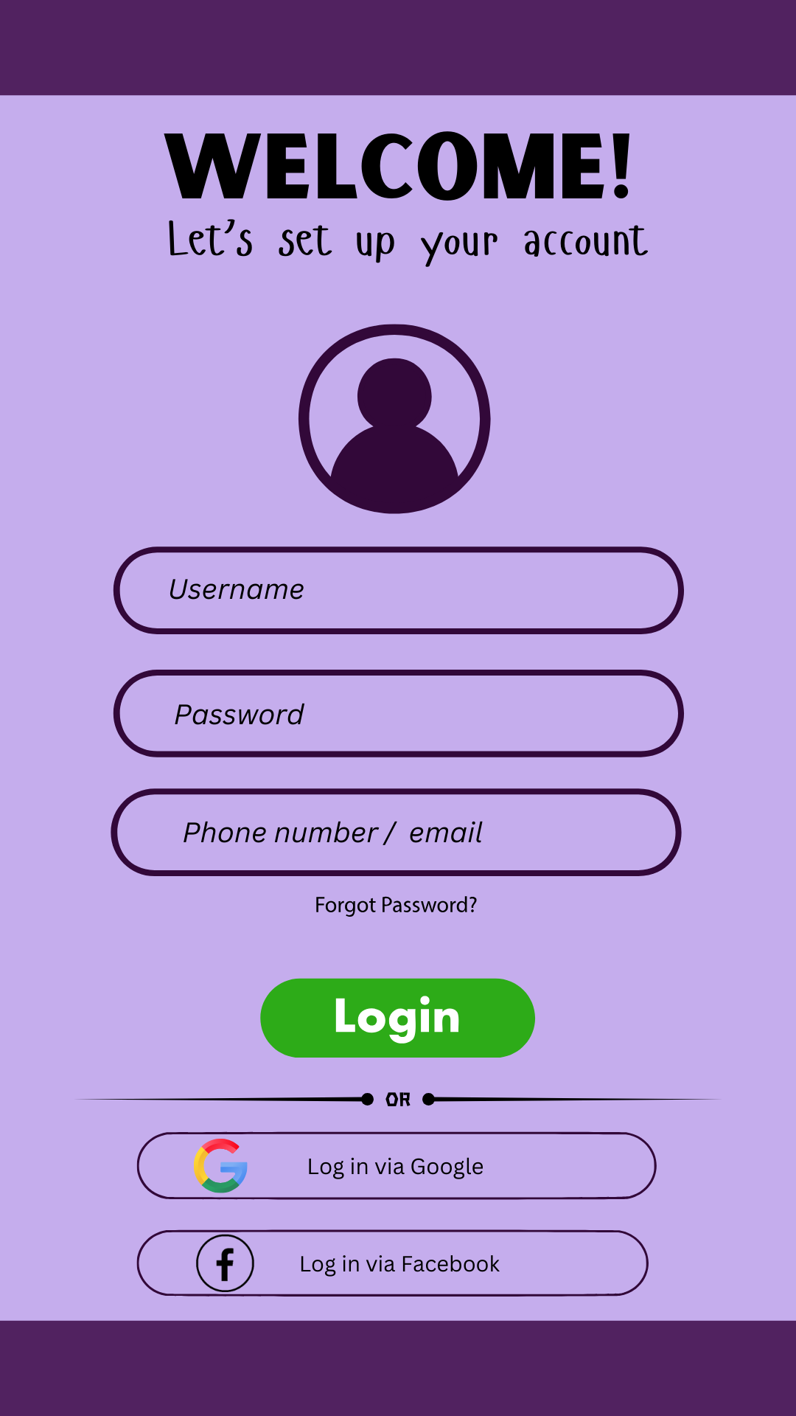

*Figure 3: Login Page* *Figure 4: Page to get user’s preferences*

The app features an intuitive search function that allows users to search grocery stores within their area of living. GROCER4U will also display the price range of each store to find the most convenient and cost-effective options. Users can mark their preferred stores by clicking a heart icon. This adds the store to their favorite stores list, making it easy for users to revisit and shop from those stores in the future. Products from each store are categorized for easy browsing, such as vegetables, beverages, and other categories. This structure simplifies the shopping process by allowing users to find items quickly.

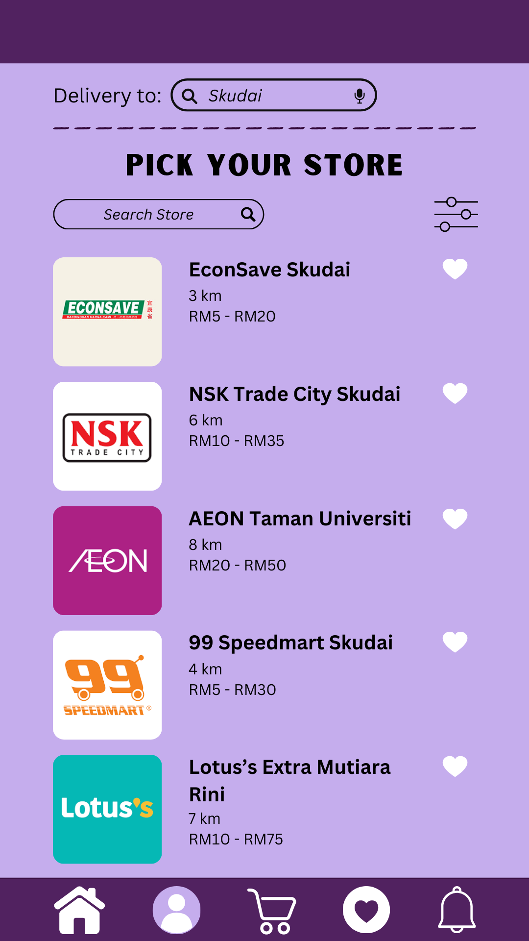 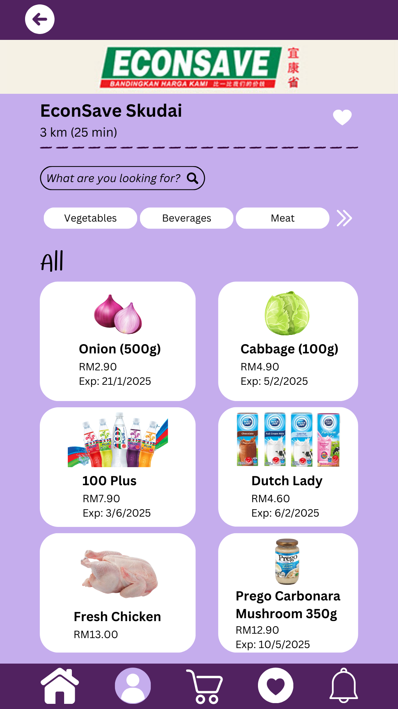

*Figure 5: Available stores choices Figure 6: Items from selected store*

The app supports multiple payment options, including credit/debit cards, digital wallets, and cash on delivery. This provides users with flexible and secure payment methods during checkout. Once an order is placed, users can track their order in real-time. Notifications keep users informed of their order status from preparation to delivery, providing transparency and peace of mind. GROCER4U will also display multiple foods' suggestions based on the purchase users made.

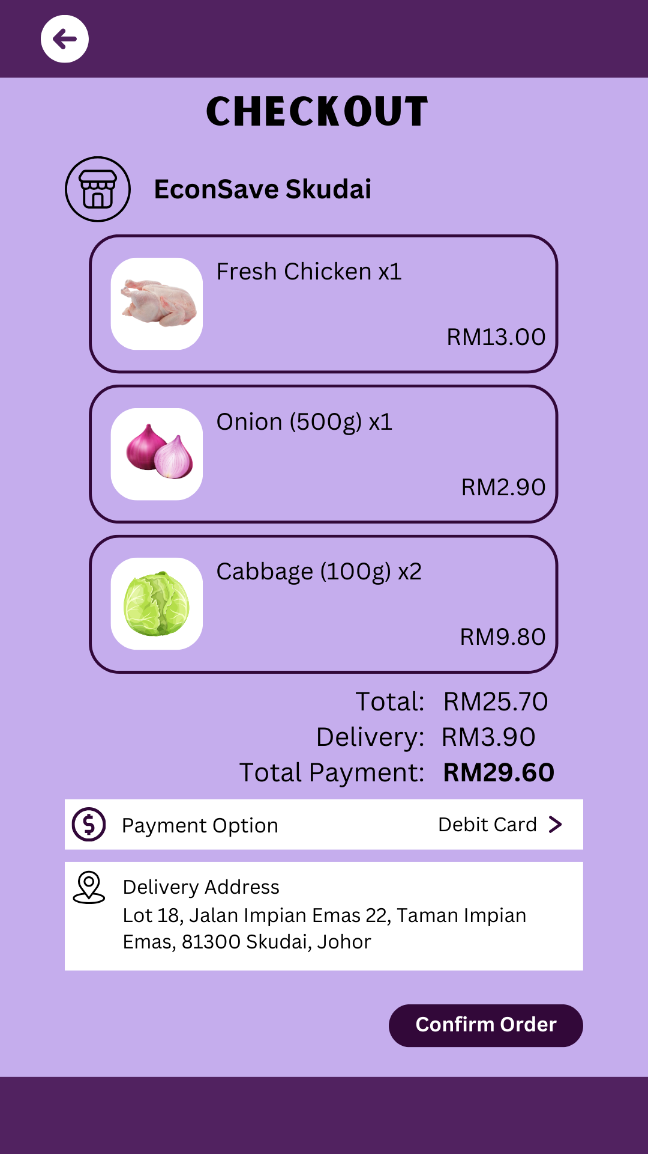 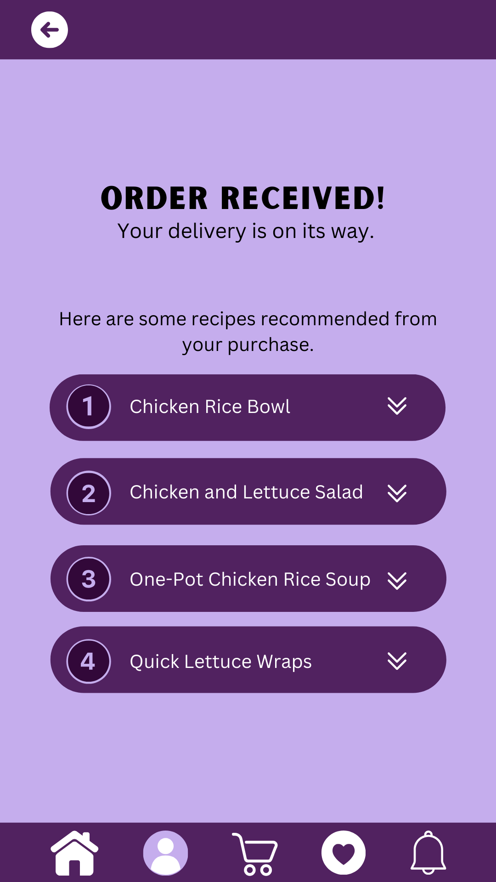

*Figure 7: Payment page Figure 8: Successful order*

After choosing which food users are interested in, GROCER4U will suggest recipes they can make with those items, helping them make the most out of their grocery haul. GROCER4U also helps users manage their groceries by tracking the expiration dates of items they have purchased. The app sends notifications when items are nearing their expiration, helping users avoid waste and use products in time.

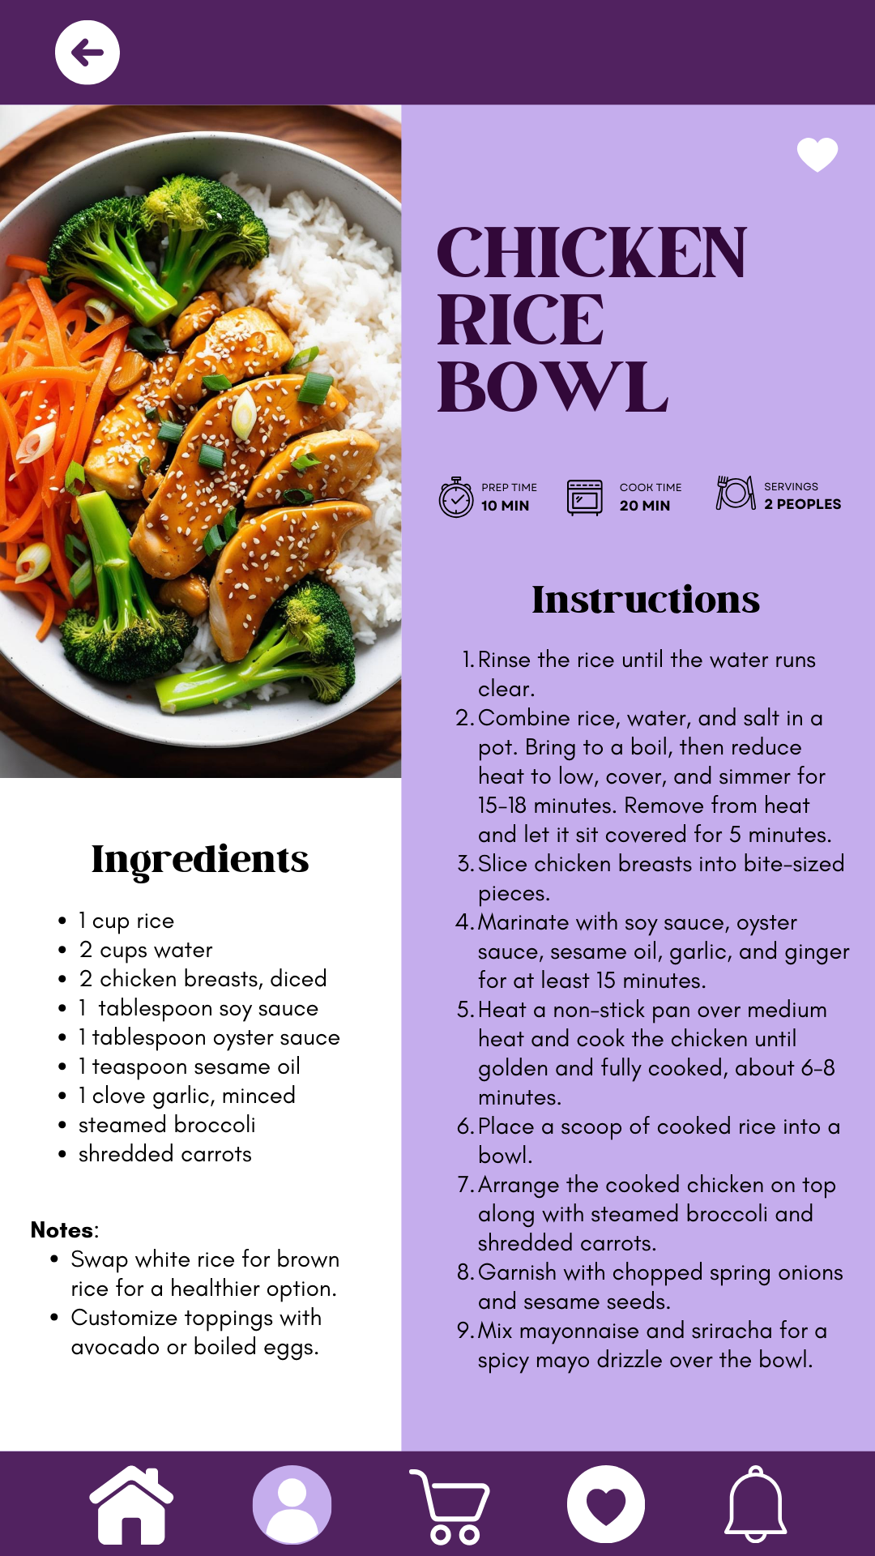 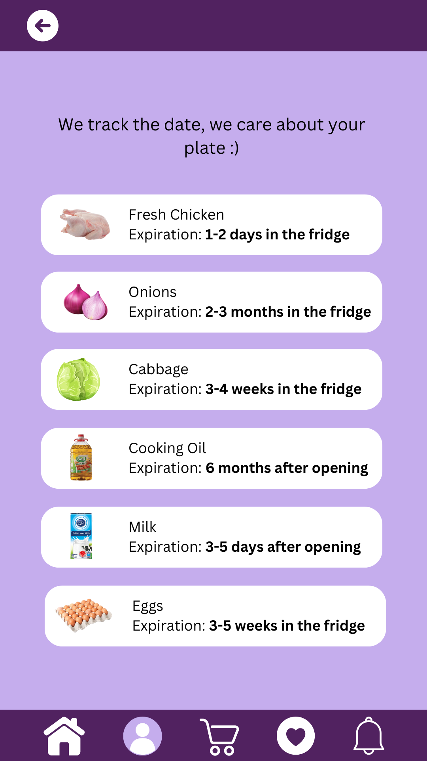

*Figure 9: Recipe Figure 10: Expiration date*

1. **USER STUDY**

To further investigate the users’ problem and requirements, interviews are conducted through short spontaneous (intercept encounters). The interviews are conducted with two groups of individuals: targeted interviewees and their family members. Interviews are conducted to get information of the users’ needs.

**Findings and Discussion Obtained from Interview**

***Background of Interviewees***

The interviewees, a diverse group ranging in age from 19 to 70, were selected through intercept encounters at multiple public places, with a total sample size of 10 participants. As illustrated in Figure 11, the participants come from various backgrounds and locations, highlighting that GROCER4U is designed to serve everyone, regardless of their place of residence.

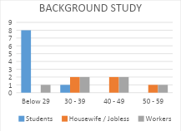

*Figure 11: Background Study of Interviewees*

***Identifying Problems Faced by Public Related to Elderly Buying Groceries***

The most common problem faced by most of the interviewees is poor meal planning and memory issues. Cognitive decline can affect the ability to plan meals or remember what groceries are needed, leading to confusion or the purchase of unnecessary or duplicate items. Some seniors may struggle to create shopping lists or remember what they have in their kitchen or fridge, leading to wasted money. Problem that matters the most is difficulty travelling to the store. Many elderly individuals experience reduced mobility due to physical limitations, chronic pain, or conditions like arthritis. This makes it challenging to travel to grocery stores and lift all the groceries they bought.

***Industry-Related Issues***

Many seniors have specific dietary requirements due to health conditions, such as low-sodium, low-sugar, or gluten-free options. However, not all grocery stores provide a wide variety of these products. The elderly might have to go to multiple stores to find the exact product or ingredient to fulfill their diet. The interviewees have suggested us to make a feature which allows the users to customize their preferred food intake. They also suggested price range features so that they can compare which store is cheaper.

***Acknowledgement of Similar Services***

From the user study, majority interviewees are aware there are other grocery delivery applications. This also includes Grab and Foodpanda. But, they also agreed that GROCER4U has its own specialty which is able to track expiration date of every product purchased and suggest menus based on the purchase. They have not seen these features in other grocery delivery applications before.

***User Feedback***

Most of the interviewees show their interests and concern on the given idea. They are comfortable with the idea and think that it should be executed in the future. However, there are some concerns and worries from the users. They are willing to use the service as long as it will not breach the user’s personal info and data. Some of them also suggest GROCER4U to ensure the delivery guy is trustworthy and free from criminal records for users' safety.

1. **CAPACITY BUILDING AND SOFT SKILLS DEVELOPMENT**

Throughout this program, we have acquired valuable experiences and developed essential soft skills that help us to better adapt in this fast-changing world. We have honed our leadership skills by guiding each other in tasks that align with our strengths. In doing so, we learned how to build cohesive teams, resolve conflicts, and foster a productive culture. Moreover, we recognised the significance of working together to achieve a shared goal, rather than working alone.

Additionally, we gained a deeper appreciation for the importance of communication. We developed the ability to express ourselves clearly, ensuring that our messages are understood by both our team members and community. These insights have strengthened our ability to connect with others, enhancing both our personal and professional relationships. Besides, this project sharpened our ability to think creatively to solve real-world problems. For example, in the first we often ignored the elderly’s needs, but now we try to think deeply about their concerns and try to solve the difficulties.

1. **REFLECTION AND CONCLUSION**

**Overall conclusion**

During the discussion, we were able to bring together our different abilities, experience, and viewpoints to ensure that the software was functional, usable, and convenient for older users. From brainstorming ideas to iterative testing, teamwork enabled us to fine-tune our solution and address any issues that arise. While conducting interviews, we also learned how to accept constructive criticism, be respectful regarding opinions of others and empathize with them.

The discussion on Grocer4U and the application reveal the contribution of this innovative product to the users’ problem. First and foremost, it provides attentive service for elderly live alone who need to pay special attention to their diet. There are several grocers and medicines selling in the app. Users can buy these things by considering the expiry date. The app will suggest the food suitable for the specific person by considering their health issues and allergies. This app helps elderly to have a better understanding regarding what they should avoid to eat for their health. For example, a diabetes patient should avoid taking sweetened cereals. This can prevent them from getting more serious diseases and irreversible damage to health.

**Personal conclusion**

a. What is your goal/dream with regard to your course/program?

b. How does this design thinking impact on your goal/dream with regard to your program?

c. What is the action/improvement/plan necessary for you to improve your potential in the industry?

**Muhammad Luqman bin Mohd Azmi:**

1. My goal is to be able to have greater understanding towards the IT field. This will allow me to contribute to society, since technology is currently expanding and evolving globally. Moreover, most of our daily lives are counting on a lot of technologies, hence by becoming an expert in the field, it is possible for us to create more innovations to solve more problems in the future.
2. The design thinking project is really a huge stepping stone for me to achieve my dreams, especially since the target users for the topic is ‘innovation for the disadvantage group’. This project allows me to see that there are tons of people that really requires help for them to go through their daily lives. Not only it teaches me to be grateful, but it also opened my eyes to see what my responsibility is as a computer science student.
3. I believe we can work together with the ministry of health to promote this app so that it can reach more audience. However, first we must improve the AI in the app, work on enhancing it to handle more users simultaneously, and do deeper research to prove that the app is even more reliable than it was, so that it is worthy to be promoted and used nationwide or even globally. Other than that, we can develop promotion or rewards system in the app for users so that it encourages them to use it more frequently.

**Nur Athirah binti Abasa:**

1. My goal is to develop practical skills and knowledge that enable me to create innovative solutions in my field. I want to contribute to projects that solve real-world problems, making everyday life easier and more efficient for people. Furthermore, I aim to build a successful career where I can combine creativity, technology, and problem-solving to make a positive impact.
2. Design thinking enhances my ability to approach challenges from a user-centred perspective. It helps me improve critical soft skills such as empathy, by understanding the needs of users, and creative problem-solving, by generating and testing innovative ideas. Through collaboration during the ideation process, I strengthen my teamwork and communication skills, which are essential in any professional environment. Additionally, design thinking develops my adaptability and critical thinking, as it encourages iterative improvements and learning from feedback. These skills are vital for achieving my goals and thriving in the industry.
3. To improve my potential, I plan to focus on both technical and interpersonal growth. This includes mastering industry-relevant tools and technologies while also developing soft skills like effective communication, collaboration, and adaptability. I aim to build a strong portfolio by working on meaningful projects that showcase my problem-solving abilities. Networking with industry professionals and participating in events will help me gain valuable insights and opportunities. Lastly, I will stay committed to continuous learning to keep up with industry trends and maintain my competitive edge.

**Batrisyia Amani binti Khairun Haled:**

1. I am hoping that this program will help meto solve practical problems, including enhancing social services and education using technology. As we all know, technology is an ever-evolving field. Thus, I am committed to lifelong learning and staying at the forefront of these changes, ensuring I am able to contribute in shaping a brighter future for all.
2. My plans to assist those in need are better organized when I use design thinking. From planning the project to interviewing the target consumers, design thinking guarantees that the solutions are useful and effective in real-world applications. By practising design thinking, I am able to make a more effective contribution to the solution of complex problems, allowing me to achieve my dream.
3. In order to maximize my potential in this field, I am committed to pursue lifelong learning through research publications and courses. This also will help me to create a network with industry experts by working on open-source projects and looking for mentorship. By remaining informed and building connections, I will be able to create opportunities for career growth.

**Tan Hui Shan:**

1. Regarding this course, I hope to learn more about the core concepts of systems and technology, along with their role in processing data. Hardware, software, networks, and databases are significant for developing a strong knowledge base. I hope this knowledge will enable me to advance in fields such as cloud computing, cybersecurity, and artificial intelligence, and equip me to analyse and solve problems related to system implementation.
2. Design thinking encourages me to think deeply about human needs. It inspires me to develop the ability to identify problems and find the best ways to solve them. The stages of design thinking—empathize, define, ideate, prototype, and test—help me become more efficient in creating designs for the future. This project also enhances my soft skills, such as teamwork, communication, problem-solving, and analysis, which are essential for anyone aiming to enter the industry.
3. To improve my potential in the industry, I need to focus on both hard and soft skills. As a computer science student, mastering programming languages such as Python, C, and HTML is indispensable. Furthermore, fields like artificial intelligence, cloud computing, IoT, and cybersecurity are becoming increasingly relevant in future trends. I plan to embark on a self-study journey by exploring the latest technologies on YouTube and utilizing GitHub to access a wide range of coding resources. Additionally, I will strive to participate in more activities organized by our faculty to enhance my communication skills and practice solving real-world problems through case studies.
4. **TASK DISTRIBUTION**

| **NAME** | **TASK** |
| --- | --- |
| Muhammad Luqman bin Mohd Azmi | * Brainstormer * Report |
| Nur Athirah binti Abasa | * Brainstormer * Prototype * Testing Prototype |
| Batrisyia Amani binti Khairun Haled | * Interviewing target user * Report |
| Tan Hui Shan | * Prototype * Video editing * Report |

1. **ATTACHMENT**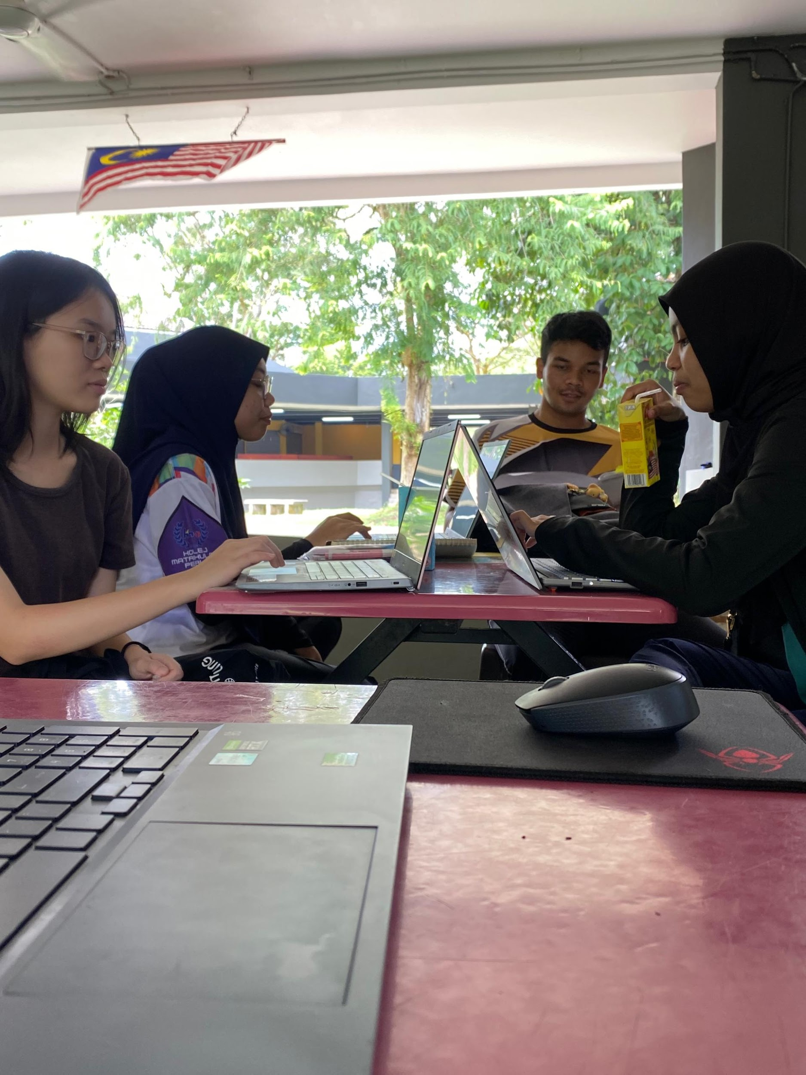

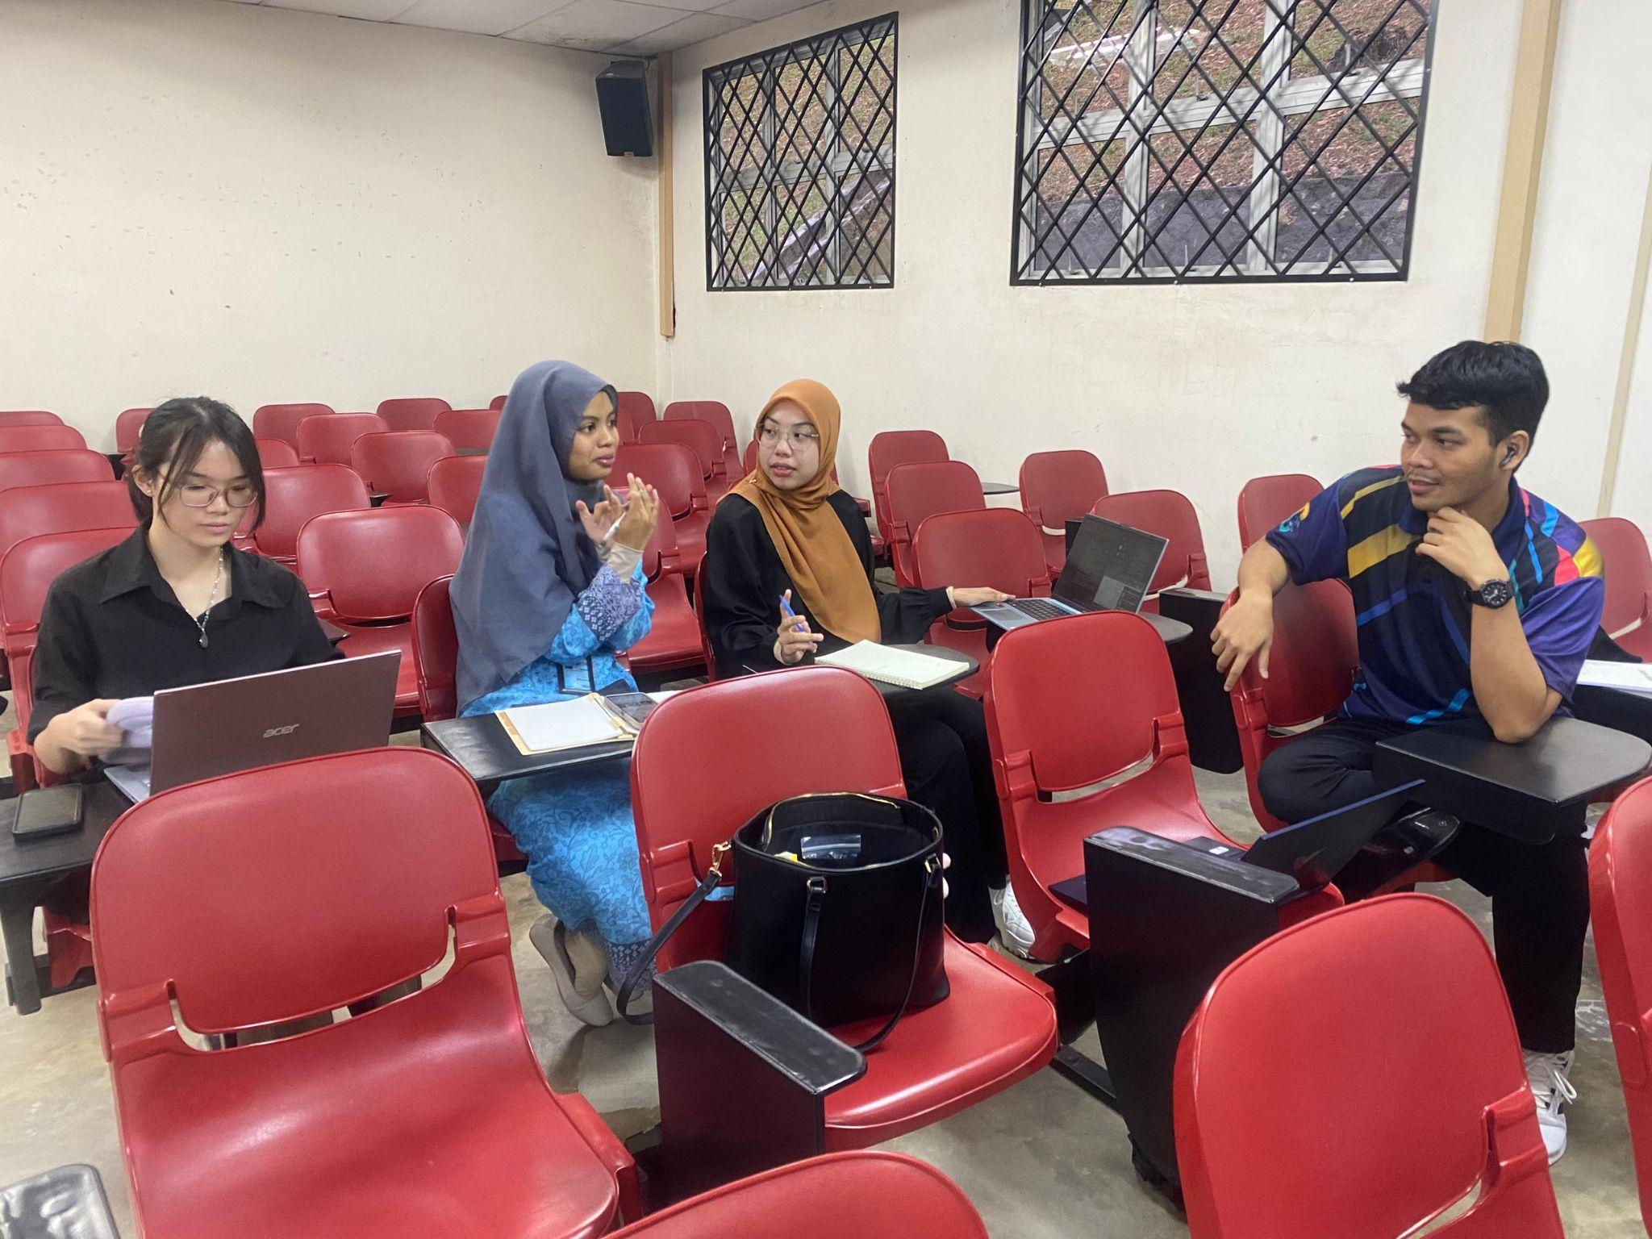 *Figure 12 : Group discussion*

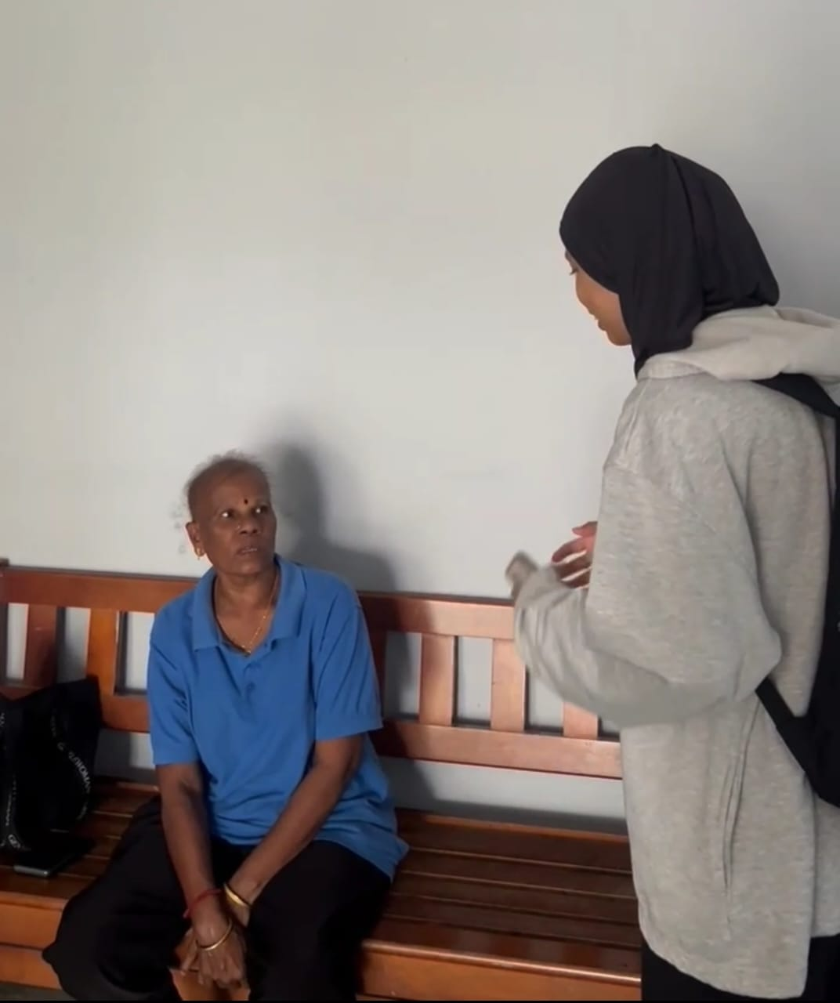

*Figure 13 : Interview session*